Practical 1
Installing Software and Running Commands In Raspberry Pi
Batch 1 Group No. 15
Steps: -
- Take out the Mouse, Keyboard and Monitor wires from the CPU
- And then connect those to the Raspberry Pi
- Insert the Memory card keeping the yellow lines circuit downside
- Connect the Charger to the plug and to the raspberry pi
- Click on Raspbian full
- Click on install icon
- Confirm the warning to yes
- It will take enough time to install
- Then set country, time zone, language
- Add a password (123)
- Skip Wifi, update software and click on Restart
- Take out the Ethernet cable of CPU and connect that to the Raspberry Pi
- Open Command Prompt and type ifconfig check the ip address 2nd line inet
192.168.2.91
- Type this in command prompt –
ls /etc/dhcpcd.conf --- this command is used to show the listing of the files
nano /etc/dhcpcd.conf --- this command is used to open a terminal based text editor
(For to change the below IP Address use this nano command)
to make changes in the static ip configuration
- Uncomment these lines
Interface eth0
Static ip_address= 192.168.2.47/24
Static routers = 192.168.0.1
And write new line under static domain_name_server_name=192.168.0.1 8.8.8.8……..
static domain_name_server_name= 8.8.8.8
If it doesn’t changes the ip address then type
set Static ip_address= 192.168.2.47/24
set Static routers = 192.168.0.1
set static domain_name_server_name= 8.8.8.8

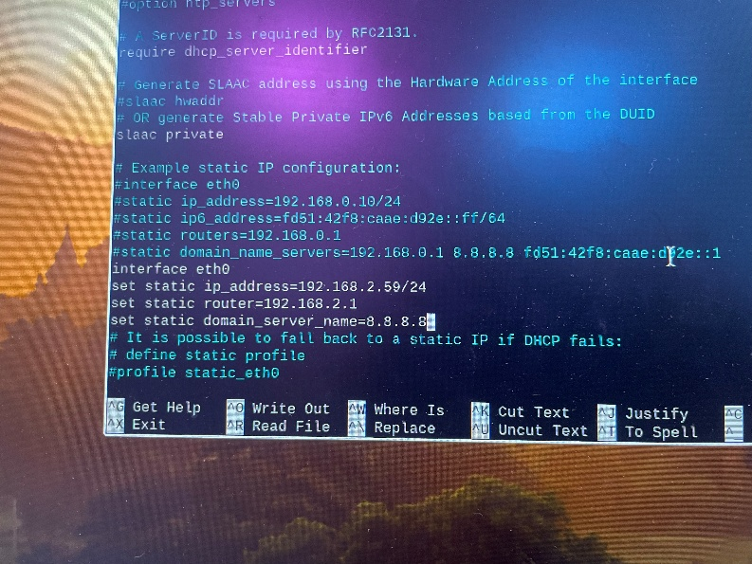
- Then do ctrl O to save
- Then enter
- Then ctrl x to exit
- Then reboot
- Again check the ip address by typing ifconfig
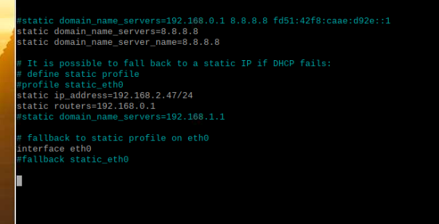
- After rebooting check again the ip address it should be updated
- In another PC command prompt type – ping 192.168.2.47
Check if the packets are received
- In Raspberry Pi PC go to the menu in Preferences > Raspberry Pi Configuration > Interfaces – enable the SSH and VNC
- For remote access of the ip address in the another machine
download VNC viewer in another pc
Untick the anonymously……
Don’t sign in
- Then Type the IP address of the Raspberry Pi (192.168.2.47) in VNC
- Enter and type username (pi) and password (123)
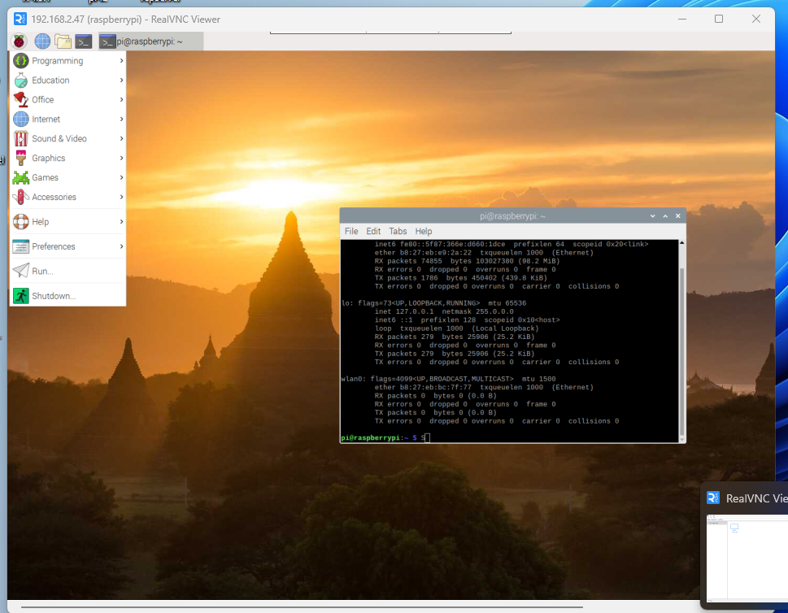
- Now Install VNC Putty from local server (192.168.2.2) soft >
VNC Putty is for Accessing the command prompt of Raspberry Pi PC on Another PC
- In that add the raspberry pi IP address (192.168.2.47)
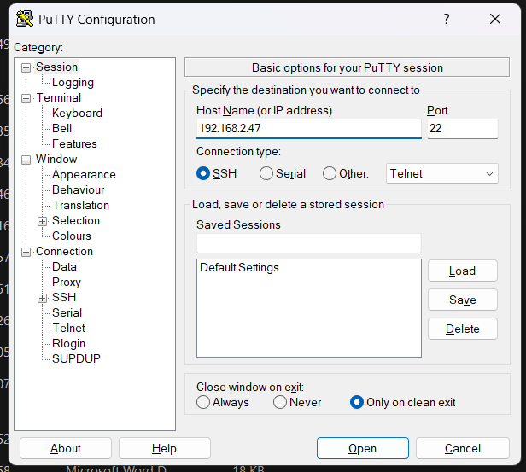
- Then click ok and a command prompt will open there add the username (pi) and password (123)
